BayShore PG HA build

Environment topology

UAT
Inventory role | Host | IP | Function
db_primary | BHC-QMSSQLU05 | 192.168.129.105 | Initial data-node primary
db_standby | BHC-QMSSQLU06 | 192.168.129.106 | Initial synchronous standby
db_monitor | BHC-QMSSQLU07 | 192.168.129.107 | Monitor and WAL archive
routing slot primary | BHC-PGBSQLU03 | 192.168.129.108 | Initial VIP MASTER and U05 pooler
routing slot standby | BHC-PGBSQLU04 | 192.168.129.109 | Initial VIP BACKUP and U06 pooler

UAT network item | Value
Cluster CIDR | 192.168.129.0/24
Application client CIDR | 192.168.24.0/24
PostgreSQL VIP | 192.168.129.110/24
NTP | 192.168.5.102, 192.168.5.101

Production

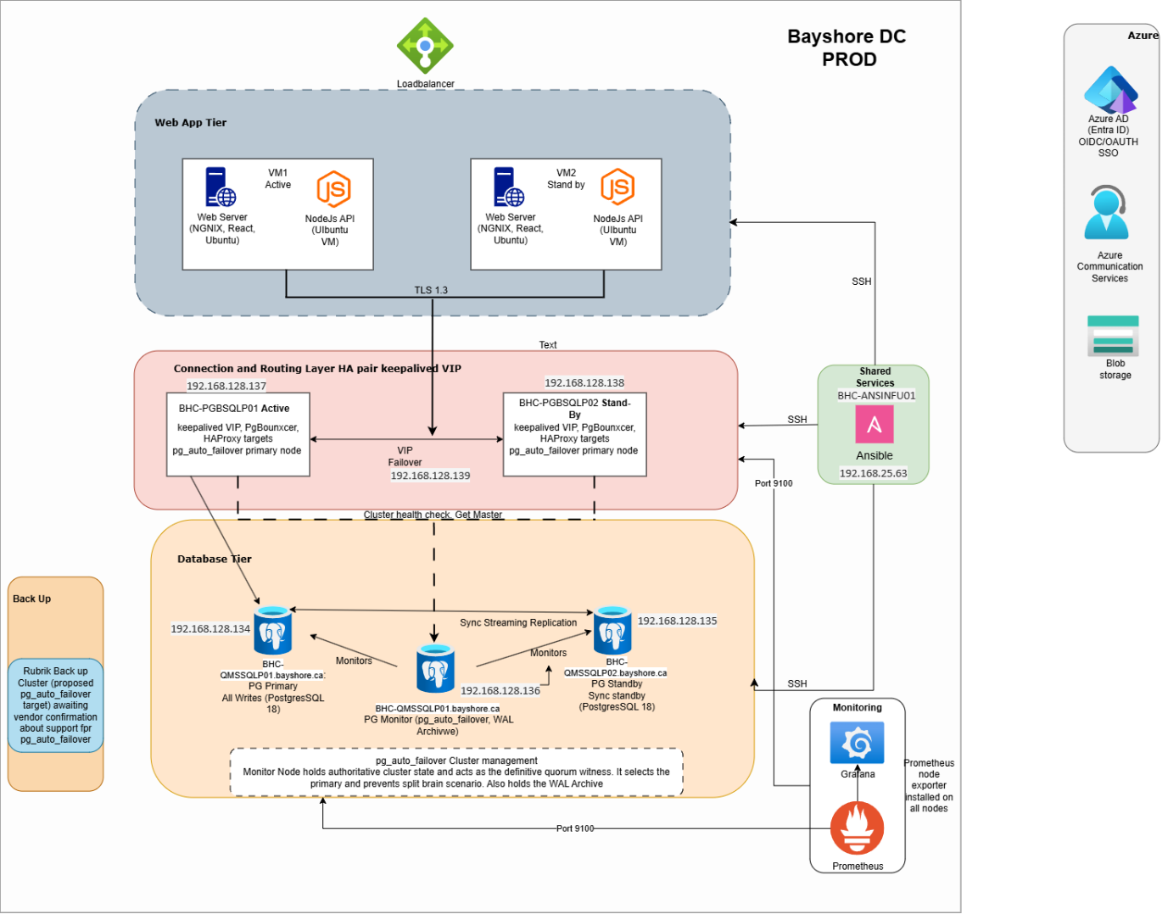

Inventory role | Host | IP | Function
db_primary | BHC-QMSSQLP01.bayshore.ca | 192.168.128.134 | Initial data-node primary
db_standby | BHC-QMSSQLP02.bayshore.ca | 192.168.128.135 | Initial synchronous standby
db_monitor | BHC-QMSSQLP03.bayshore.ca | 192.168.128.136 | Monitor and WAL archive
routing slot primary | BHC-PGBSQLP01 | 192.168.128.137 | Initial VIP MASTER and P01 pooler
routing slot standby | BHC-PGBSQLP02 | 192.168.128.138 | Initial VIP BACKUP and P02 pooler

Production network item | Value
Cluster CIDR | 192.168.128.0/24
Application client CIDR | 192.168.4.0/24
PostgreSQL VIP/DNS | PGBQMSLSP01, 192.168.128.139/24
Prometheus | BHC-PGMSQLP01, 192.168.128.140
NTP | 192.168.5.102, 192.168.5.101

Normal write path
The application connects to the environment VIP on port 5432.
Keepalived places that VIP on exactly one routing node.
HAProxy considers both routing-node PgBouncer services as backends.
/usr/local/sbin/check-pg-primary maps each router to its paired database and runs SELECT pg_is_in_recovery().
Only the pooler paired with a node returning false is eligible.
PgBouncer forwards the transaction to PostgreSQL.
The fixed pairings are:
Environment | Router | Database candidate
UAT | U03 | U05
UAT | U04 | U06
Production | routing P01 | database P01
Production | routing P02 | database P02

Database failover flow
Primary failure
-> monitor confirms health/state conditions
-> standby is promoted
-> HAProxy check detects new writable node
-> corresponding PgBouncer backend becomes UP
-> VIP remains available through routing tier
The monitor, not an operator-issued pg_ctl promote, orchestrates the state transition and split-brain prevention states.

Routing failover flow
Active router/HAProxy failure
-> Keepalived health/VRRP detects loss
-> peer router acquires VIP
-> peer HAProxy selects writable-primary-paired PgBouncer
-> clients reconnect to the same VIP

Component architecture

PostgreSQL and pg_auto_failover
PostgreSQL 18 runs under pg_autoctl.service; the Debian wrapper service is not the database supervisor.
The monitor database records node identities, reported states, assigned states, health, and orchestration decisions.
The initial inventory role is not permanent. After failover, db_standby may be the current primary.
Synchronous replication is managed dynamically. A healthy two-node cluster protects committed data according to its configured quorum policy; loss of a standby can cause availability-oriented policy changes.
Data nodes and monitor use self-signed TLS with sslmode=require unless enterprise certificates replace it.

Routing tier
PgBouncer listens on 6432 with transaction pooling.
HAProxy listens on the VIP at 5432 and exposes local statistics at 8404.
Keepalived uses unicast VRRP, priority 101/100, and tracks HAProxy.
A PgBouncer failure removes that backend from HAProxy. Because each HAProxy lists both poolers, the peer pooler can still be used.
An HAProxy failure reduces Keepalived priority so the peer should own the VIP.
Storage
Database-side logical volumes use XFS:
LV | Size | Intended mount
lv_data | 100 GiB | /pgdata/pgroot
lv_wal | 300 GiB | /pgdata/wal
lv_log | 30 GiB | /pgdata/log
lv_tmp | 30 GiB | /pgdata/tmp
lv_binaries | 100 GiB | /pgdata/binaries
lv_dbinst | 100 GiB | /pgdata/dbinst

PGDATA is /pgdata/pgroot/data, an ordinary directory. The WAL filesystem is bind-mounted at $PGDATA/pg_wal. Keeping data and sibling backup on the same XFS filesystem permits pg_autoctl to atomically rename a completed base backup into place.
The monitor owns /pgdata/WalArchive. Production P03 uses the pre-provisioned 405 GB /dev/sdc1 XFS filesystem for this mount. Each routing node has one 120 GB /dev/sdb1 XFS filesystem mounted at /pgdata, not /pgdata/pgroot.

WAL archive and backup integration
Each data node has a dedicated Ed25519 key. archive_command calls /usr/local/sbin/archive-wal, which:
checks whether the final segment already exists;
sends the segment as <name>.partial with rsync over SSH;
atomically renames it on the monitor;
optionally invokes the Rubrik RBS hook.
The durable configuration chain is:
postgresql.conf
└── postgresql-ha.conf
└── postgresql-archive.conf
This prevents pg_autoctl from removing archive settings when it regenerates its base configuration. Required settings include wal_level=replica, archive_mode=on, and the archive helper command.
WAL files alone are not a restorable backup. A tested base backup plus an unbroken WAL sequence and configuration recovery procedure are required for PITR.

Network and firewall
Source | Destination | Protocol/port | Purpose
Control/operator networks | all nodes | TCP 22 | Ansible and SSH
Prometheus source | all nodes | TCP 9100 | node exporter
Prometheus source | DB nodes | TCP 9187 | PostgreSQL exporter
Prometheus source | routers | TCP 9127 | PgBouncer exporter
Application CIDRs | routing VIP/nodes | TCP 5432 | database service
Cluster/router CIDRs | routers | TCP 6432 | HAProxy to PgBouncer
DB/monitor cluster peers | DB nodes | TCP 5432 | PostgreSQL and monitor
Data nodes | monitor | TCP 22 | WAL archive transport
Routing peers | routing peers | IP protocol 112 | VRRP
All nodes | NTP sources | UDP 123 | time synchronization

UFW defaults to deny incoming and allow outgoing. The role can reset undeclared rules, so emergency firewall rules must be added to Ansible before the next normal deployment.

Time synchronization
Chrony is installed on all nodes with iburst, bounded polling, makestep, and RTC synchronization. Cluster initialization waits for a normal leap status. Time failure does not directly stop an already running database, but it makes incident timelines, monitoring, TLS validation, and coordinated HA operations unreliable. Correct time before rejoining a node.

Monitoring
Component | Port | Scope
node exporter | 9100 | all nodes
PostgreSQL exporter | 9187 | data and monitor nodes
PgBouncer exporter | 9127 | routing nodes
HAProxy stats | 8404 | local/approved monitoring access

